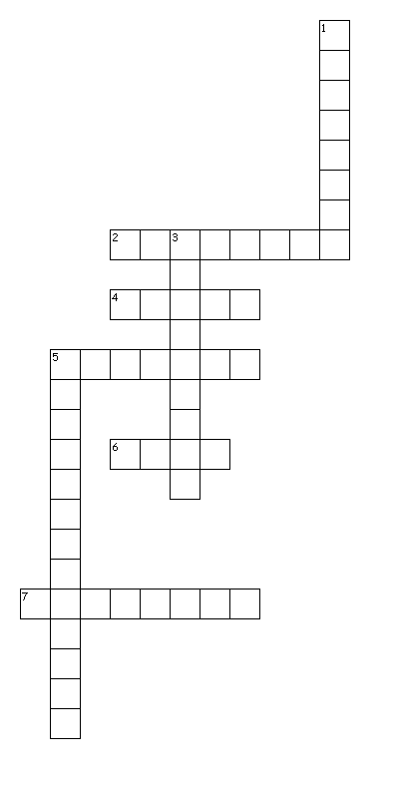
Across
2. Helps to build red blood cells. It also helps the blood carry oxygen from the lungs to each body cell.
4. Needed to carry other nutrients, to regulate body temperature, and to help eliminate wastes, makes up about 60 percent of an adult's body weight.
5. Builds bones and teeth, and it is necessary for blood clotting.
6. Makes certain vitamins available for use in the body, they cushion vital organs, they make up part of all body cells, and they help to maintain body temperature.
7. Made of amino acids, small units necessary for growth and tissue repair.

Down
1. Needed for growth and health. The body either cannot manufacture them at all or cannot normally manufacture them in sufficient amounts, and so must absorb them from food.
3. Essential, the human body must have in order to function.
5. The main source of the body's energy, food sources are rice, wheat, corn, and potatoes.

8 of 8 words were placed into the puzzle.
Created by Puzzlemaker at DiscoveryEducation.com



Nutrients

Nutrient Answer Key

